# Lab 13 – Full Wave Rectifier & Biased Transistor

## Exercise

### Exercise 1

Using PSPICE design a full wave rectifier

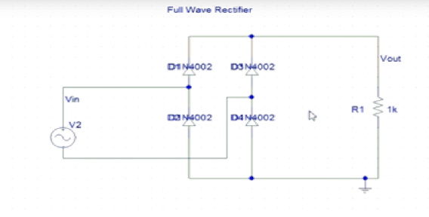

Figure 13-9 Full Wave Rectifier

**Circuit:**

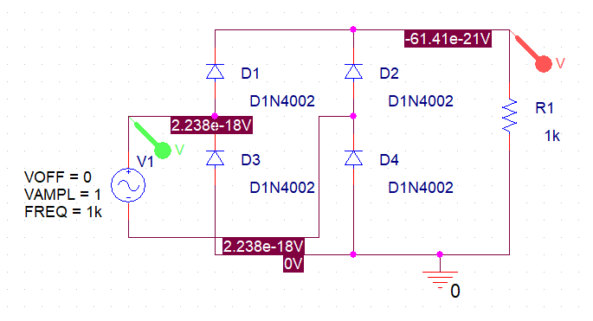

**Output:**

